library(ggplot2)  
library(readxl)  
movies.dataset <- read_excel("tmdb_5000_movies.xls")  
summary(movies.dataset)

## budget genres homepage   
## Min. : 0 Length:4803 Length:4803   
## 1st Qu.: 790000 Class :character Class :character   
## Median : 15000000 Mode :character Mode :character   
## Mean : 29045040   
## 3rd Qu.: 40000000   
## Max. :380000000   
##   
## id keywords original_language original_title   
## Min. : 5 Length:4803 Length:4803 Length:4803   
## 1st Qu.: 9014 Class :character Class :character Class :character   
## Median : 14629 Mode :character Mode :character Mode :character   
## Mean : 57166   
## 3rd Qu.: 58611   
## Max. :459488   
##   
## overview popularity production_companies  
## Length:4803 Min. : 0.000 Length:4803   
## Class :character 1st Qu.: 4.668 Class :character   
## Mode :character Median : 12.922 Mode :character   
## Mean : 21.492   
## 3rd Qu.: 28.314   
## Max. :875.581   
##   
## production_countries release_date revenue   
## Length:4803 Min. :1916-09-04 00:00:00 Min. :0.000e+00   
## Class :character 1st Qu.:1999-07-14 00:00:00 1st Qu.:0.000e+00   
## Mode :character Median :2005-10-03 00:00:00 Median :1.917e+07   
## Mean :2002-12-27 23:45:54 Mean :8.226e+07   
## 3rd Qu.:2011-02-16 00:00:00 3rd Qu.:9.292e+07   
## Max. :2017-02-03 00:00:00 Max. :2.788e+09   
## NA's :1   
## runtime spoken_languages status tagline   
## Min. : 0.0 Length:4803 Length:4803 Length:4803   
## 1st Qu.: 94.0 Class :character Class :character Class :character   
## Median :103.0 Mode :character Mode :character Mode :character   
## Mean :106.9   
## 3rd Qu.:118.0   
## Max. :338.0   
## NA's :2   
## title vote_average vote_count   
## Length:4803 Min. : 0.000 Min. : 0.0   
## Class :character 1st Qu.: 5.600 1st Qu.: 54.0   
## Mode :character Median : 6.200 Median : 235.0   
## Mean : 6.092 Mean : 690.2   
## 3rd Qu.: 6.800 3rd Qu.: 737.0   
## Max. :10.000 Max. :13752.0   
##

str(movies.dataset)

## Classes 'tbl_df', 'tbl' and 'data.frame': 4803 obs. of 20 variables:  
## $ budget : num 2.37e+08 3.00e+08 2.45e+08 2.50e+08 2.60e+08 2.58e+08 2.60e+08 2.80e+08 2.50e+08 2.50e+08 ...  
## $ genres : chr "[{\"id\": 28, \"name\": \"Action\"}, {\"id\": 12, \"name\": \"Adventure\"}, {\"id\": 14, \"name\": \"Fantasy\"}"| __truncated__ "[{\"id\": 12, \"name\": \"Adventure\"}, {\"id\": 14, \"name\": \"Fantasy\"}, {\"id\": 28, \"name\": \"Action\"}]" "[{\"id\": 28, \"name\": \"Action\"}, {\"id\": 12, \"name\": \"Adventure\"}, {\"id\": 80, \"name\": \"Crime\"}]" "[{\"id\": 28, \"name\": \"Action\"}, {\"id\": 80, \"name\": \"Crime\"}, {\"id\": 18, \"name\": \"Drama\"}, {\"i"| __truncated__ ...  
## $ homepage : chr "http://www.avatarmovie.com/" "http://disney.go.com/disneypictures/pirates/" "http://www.sonypictures.com/movies/spectre/" "http://www.thedarkknightrises.com/" ...  
## $ id : num 19995 285 206647 49026 49529 ...  
## $ keywords : chr "[{\"id\": 1463, \"name\": \"culture clash\"}, {\"id\": 2964, \"name\": \"future\"}, {\"id\": 3386, \"name\": \""| __truncated__ "[{\"id\": 270, \"name\": \"ocean\"}, {\"id\": 726, \"name\": \"drug abuse\"}, {\"id\": 911, \"name\": \"exotic "| __truncated__ "[{\"id\": 470, \"name\": \"spy\"}, {\"id\": 818, \"name\": \"based on novel\"}, {\"id\": 4289, \"name\": \"secr"| __truncated__ "[{\"id\": 849, \"name\": \"dc comics\"}, {\"id\": 853, \"name\": \"crime fighter\"}, {\"id\": 949, \"name\": \""| __truncated__ ...  
## $ original_language : chr "en" "en" "en" "en" ...  
## $ original_title : chr "Avatar" "Pirates of the Caribbean: At World's End" "Spectre" "The Dark Knight Rises" ...  
## $ overview : chr "In the 22nd century, a paraplegic Marine is dispatched to the moon Pandora on a unique mission, but becomes tor"| __truncated__ "Captain Barbossa, long believed to be dead, has come back to life and is headed to the edge of the Earth with W"| __truncated__ "A cryptic message from Bondâ\200\231s past sends him on a trail to uncover a sinister organization. While M bat"| __truncated__ "Following the death of District Attorney Harvey Dent, Batman assumes responsibility for Dent's crimes to protec"| __truncated__ ...  
## $ popularity : num 150.4 139.1 107.4 112.3 43.9 ...  
## $ production_companies: chr "[{\"name\": \"Ingenious Film Partners\", \"id\": 289}, {\"name\": \"Twentieth Century Fox Film Corporation\", \"| __truncated__ "[{\"name\": \"Walt Disney Pictures\", \"id\": 2}, {\"name\": \"Jerry Bruckheimer Films\", \"id\": 130}, {\"name"| __truncated__ "[{\"name\": \"Columbia Pictures\", \"id\": 5}, {\"name\": \"Danjaq\", \"id\": 10761}, {\"name\": \"B24\", \"id\": 69434}]" "[{\"name\": \"Legendary Pictures\", \"id\": 923}, {\"name\": \"Warner Bros.\", \"id\": 6194}, {\"name\": \"DC E"| __truncated__ ...  
## $ production_countries: chr "[{\"iso_3166_1\": \"US\", \"name\": \"United States of America\"}, {\"iso_3166_1\": \"GB\", \"name\": \"United Kingdom\"}]" "[{\"iso_3166_1\": \"US\", \"name\": \"United States of America\"}]" "[{\"iso_3166_1\": \"GB\", \"name\": \"United Kingdom\"}, {\"iso_3166_1\": \"US\", \"name\": \"United States of America\"}]" "[{\"iso_3166_1\": \"US\", \"name\": \"United States of America\"}]" ...  
## $ release_date : POSIXct, format: "2009-12-10" "2007-05-19" ...  
## $ revenue : num 2.79e+09 9.61e+08 8.81e+08 1.08e+09 2.84e+08 ...  
## $ runtime : num 162 169 148 165 132 139 100 141 153 151 ...  
## $ spoken_languages : chr "[{\"iso_639_1\": \"en\", \"name\": \"English\"}, {\"iso_639_1\": \"es\", \"name\": \"Espa\\u00f1ol\"}]" "[{\"iso_639_1\": \"en\", \"name\": \"English\"}]" "[{\"iso_639_1\": \"fr\", \"name\": \"Fran\\u00e7ais\"}, {\"iso_639_1\": \"en\", \"name\": \"English\"}, {\"iso_"| __truncated__ "[{\"iso_639_1\": \"en\", \"name\": \"English\"}]" ...  
## $ status : chr "Released" "Released" "Released" "Released" ...  
## $ tagline : chr "Enter the World of Pandora." "At the end of the world, the adventure begins." "A Plan No One Escapes" "The Legend Ends" ...  
## $ title : chr "Avatar" "Pirates of the Caribbean: At World's End" "Spectre" "The Dark Knight Rises" ...  
## $ vote_average : num 7.2 6.9 6.3 7.6 6.1 5.9 7.4 7.3 7.4 5.7 ...  
## $ vote_count : num 11800 4500 4466 9106 2124 ...

ggplot(movies.dataset, aes(vote_average, revenue))+geom_point()

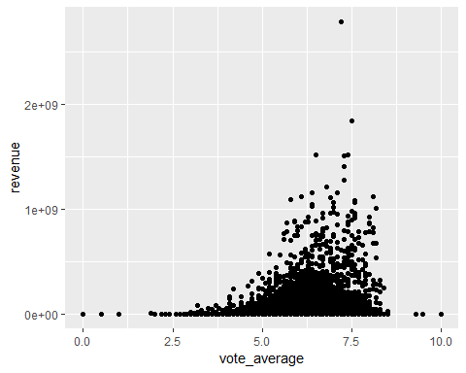

ggplot(movies.dataset, aes(vote_average, revenue))+geom_point(colour="red")

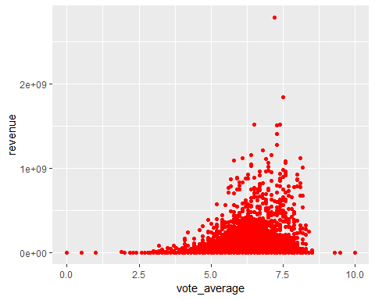

ggplot(movies.dataset, aes(budget, revenue))+geom_point()+geom_smooth()

## `geom_smooth()` using method = 'gam' and formula 'y ~ s(x, bs = "cs")'

